Decision 4 – Stata vs app: Research Baseline and Research Specification
Research Baseline – Options List Length – Tendency to Plan score
Agents 280 · Income: not used · β0 = 0 (Stata: no intercept) · σ: none
Stata: histogram weighted_ttp | App: Research Baseline
 | 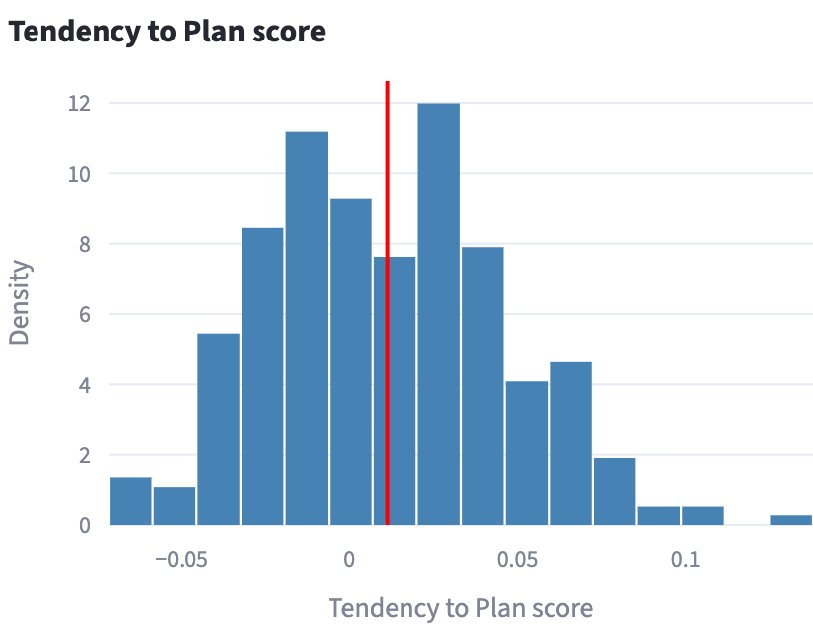
Match
Research Baseline – Options List Length – number of pre-selected options
Agents 280 · Income: not used · β0 = 0 (Stata: no intercept) · σ: none
Stata: histogram choice_length_deterministic | App: Research Baseline
 | 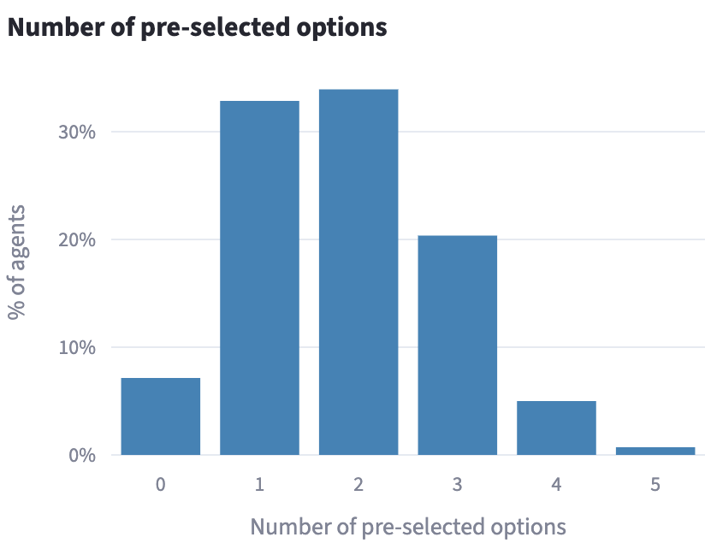
Match (7.1 / 32.9 / 33.9 / 20.4 / 5.0 / 0.7 % of agents for 0–5 options). Stata's y-axis is density, the app's is % of agents but the shape is the same.
Research Baseline – Loyalty – score
Agents 280 · Income: not used · β1 = 0 · σ: none
Stata: histogram weighted_loyalty | App: Research Baseline
 | 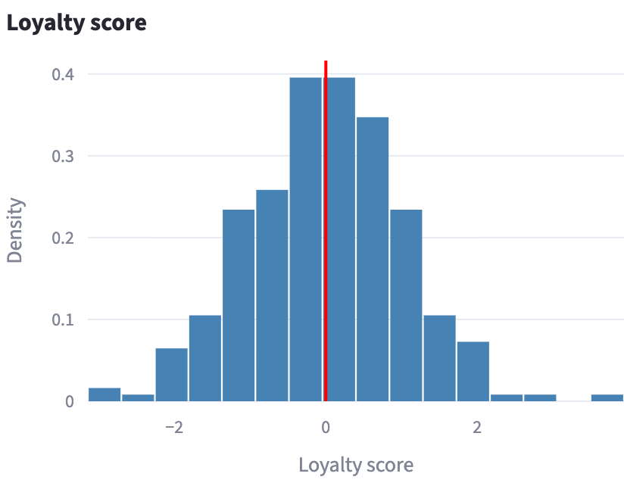
Match
Research Baseline – Loyalty – options ranking
Agents 280 · Income: not used · β1 = 0 · σ: none
Stata: histogram weighted_loyalty15 | App: Research Baseline
 | 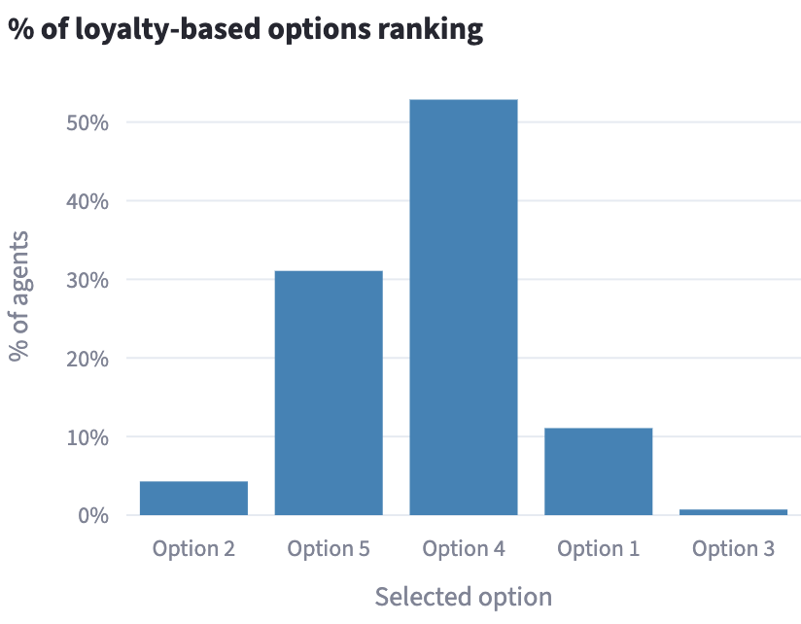
Match (4.3 / 31.1 / 52.9 / 11.1 / 0.7 % of agents). Stata's y-axis is density, the app's is % of agents, and Stata numbers the bars 1–5 where the app names them by option, but the shape is the same.
Research Baseline – Willingness-to-Pay – score (continuous income)
Agents 280 · Income: Continuous only · β2 = 0 · σ: none
Stata: histogram z_WTP_calculated | App: Research Baseline
 | 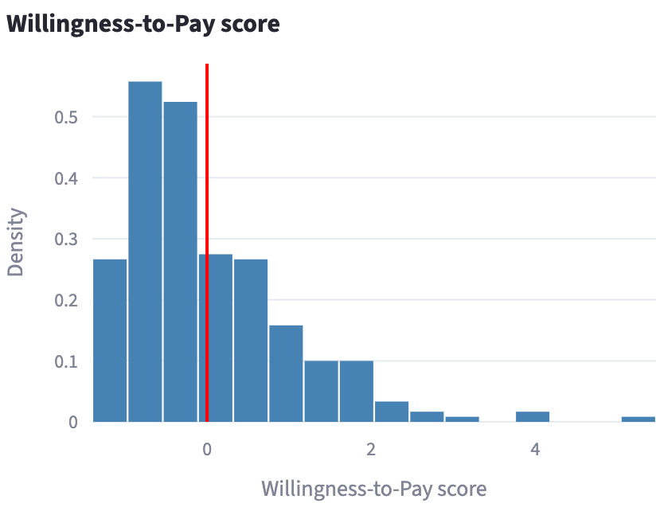
Match
Research Baseline – Willingness-to-Pay – options ranking (continuous income)
Agents 280 · Income: Continuous only · β2 = 0 · σ: none
Stata: histogram WTP_calculated15 | App: Research Baseline
 | 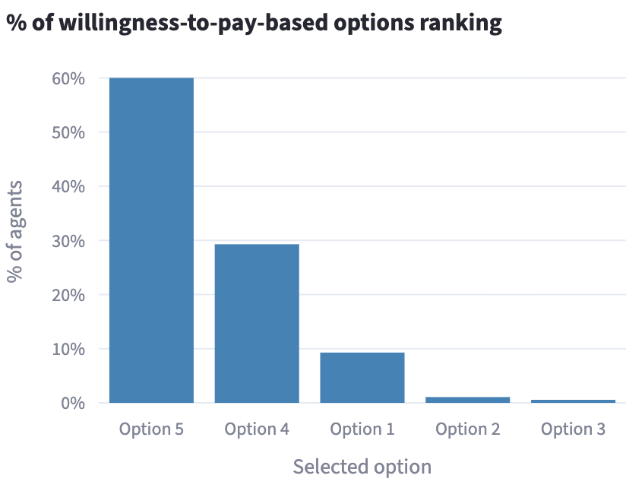
Match (60.0 / 29.3 / 9.3 / 1.1 / 0.4 % of agents). Stata's y-axis is density, the app's is % of agents, and Stata numbers the bars 1–5 where the app names them by option, but the shape is the same.
Research Baseline – Willingness-to-Pay – score (categorical income)
Agents 280 · Income: Categorical only · β2 = 0 · σ: none
Stata: histogram z_WTP_categorical | App: Research Baseline
 | 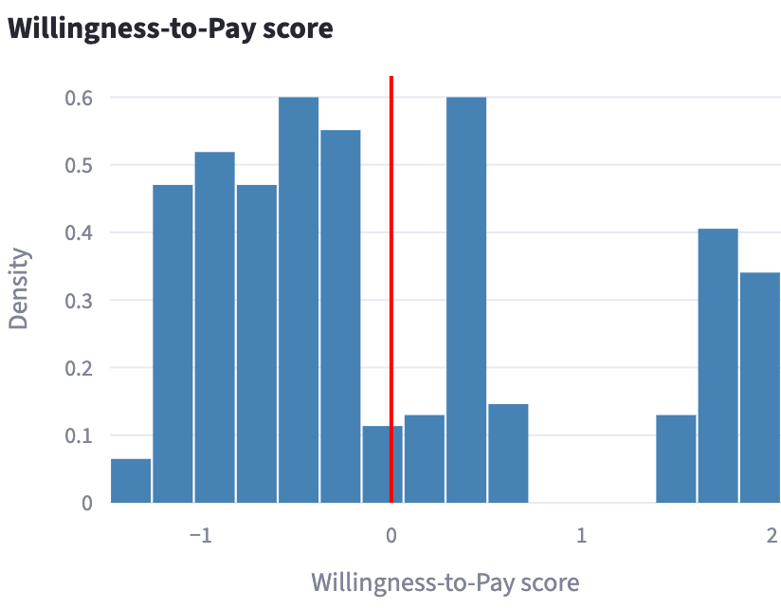
Does not match. In the Stata file, the lowest allowance level (57 participants) used the raw Agreeableness score instead of the standardised one; the other levels and the document use the standardised one, as the app does. Re-running Stata with that fix should make the graphs match.
Research Baseline – Risk-Taking – score (continuous income)
Agents 280 · Income: Continuous only · β3 = 0 · σ: none
Stata: histogram z_RT_calculated_hs | App: Research Baseline
 | 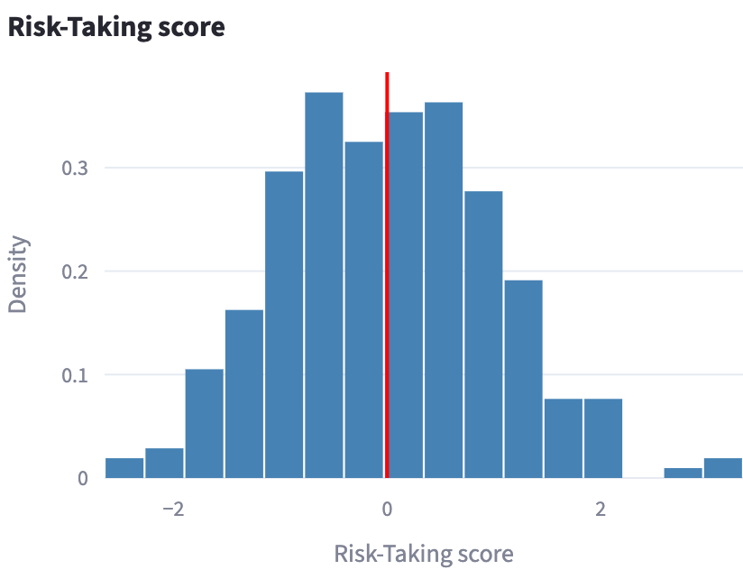
Match
Research Baseline – Risk-Taking – options ranking (continuous income)
Agents 280 · Income: Continuous only · β3 = 0 · σ: none
Stata: histogram RT_calculated15 | App: Research Baseline
 | 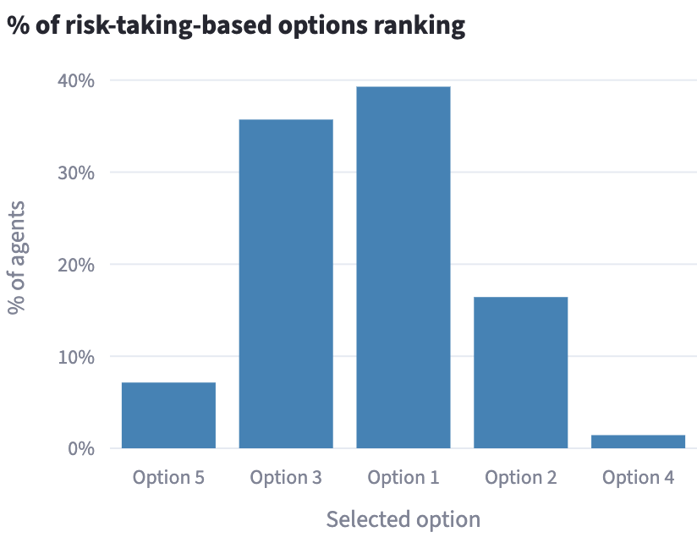
Match (7.1 / 35.7 / 39.3 / 16.4 / 1.4 % of agents). Stata's y-axis is density, the app's is % of agents, and Stata numbers the bars 1–5 where the app names them by option, but the shape is the same.
Research Baseline – Risk-Taking – score (categorical income)
Agents 280 · Income: Categorical only · β3 = 0 · σ: none
Stata: histogram z_RT_categorical | App: Research Baseline
 | 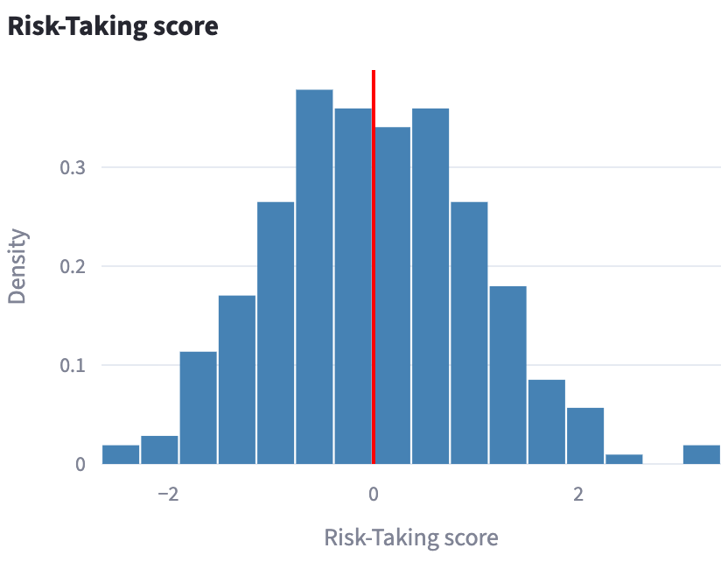
Match
Research Baseline – Flexibility – score
Agents 280 · Income: not used · β4 = 0 · σ: none
Stata: histogram z_anchored_flexibility | App: Research Baseline
 | 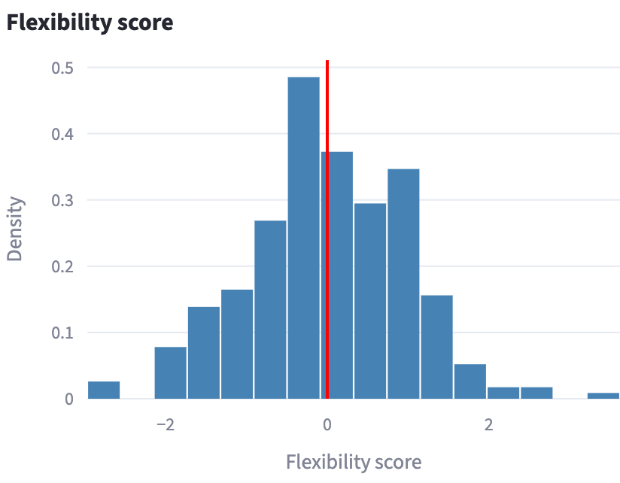
Match
Research Baseline – Flexibility – options ranking
Agents 280 · Income: not used · β4 = 0 · σ: none
Stata: histogram Flexibility_combined15 | App: Research Baseline
 | 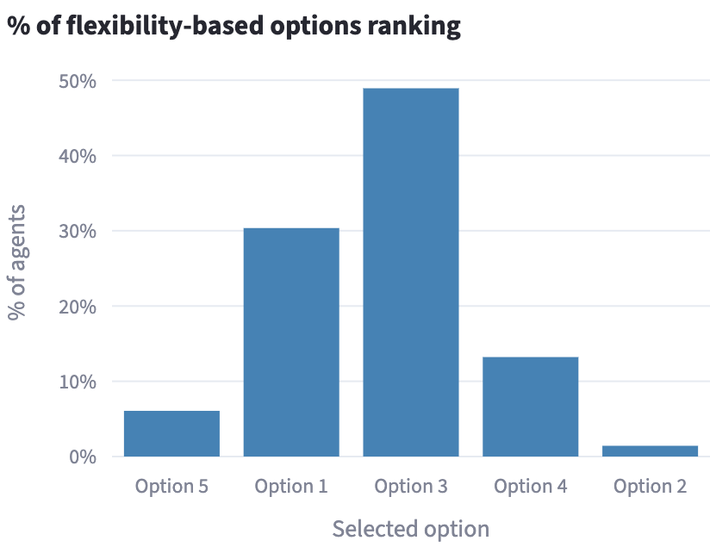
Match (6.1 / 30.4 / 48.9 / 13.2 / 1.4 % of agents). Stata's y-axis is density, the app's is % of agents, and Stata numbers the bars 1–5 where the app names them by option, but the shape is the same.

Research Specification – Options List Length – Tendency to Plan score
Agents 280 · Income: not used · β0 = 0 (Stata: no intercept) · σ: none (turned off in the app)
Stata: histogram weighted_ttp | App: Research Specification
Match
Research Specification – Options List Length – number of pre-selected options
Agents 280 · Income: not used · β0 = 0 (Stata: no intercept) · σ: none (turned off in the app)
Stata: histogram choice_length_deterministic | App: Research Specification
Match (7.1 / 32.9 / 33.9 / 20.4 / 5.0 / 0.7 % of agents for 0–5 options). Stata's y-axis is density, the app's is % of agents but the shape is the same.
Research Specification – Loyalty – score
Agents 280 · Income: not used · β1 = 0 · σ: none (turned off in the app)
Stata: histogram weighted_loyalty | App: Research Specification
Match
Research Specification – Loyalty – options ranking
Agents 280 · Income: not used · β1 = 0 · σ: none (turned off in the app)
Stata: histogram weighted_loyalty15 | App: Research Specification
Match (4.3 / 31.1 / 52.9 / 11.1 / 0.7 % of agents). Stata's y-axis is density, the app's is % of agents, and Stata numbers the bars 1–5 where the app names them by option, but the shape is the same.
Research Specification – Willingness-to-Pay – score (continuous income)
Agents 280 · Income: Continuous only · β2 = 0 · σ: none (turned off in the app)
Stata: histogram z_WTP_calculated | App: Research Specification
Match
Research Specification – Willingness-to-Pay – options ranking (continuous income)
Agents 280 · Income: Continuous only · β2 = 0 · σ: none (turned off in the app)
Stata: histogram WTP_calculated15 | App: Research Specification
Match (60.0 / 29.3 / 9.3 / 1.1 / 0.4 % of agents). Stata's y-axis is density, the app's is % of agents, and Stata numbers the bars 1–5 where the app names them by option, but the shape is the same.
Research Specification – Willingness-to-Pay – score (categorical income)
Agents 280 · Income: Categorical only · β2 = 0 · σ: none (turned off in the app)
Stata: histogram z_WTP_categorical | App: Research Specification
Does not match. In the Stata file, the lowest allowance level (57 participants) used the raw Agreeableness score instead of the standardised one; the other levels and the document use the standardised one, as the app does. Re-running Stata with that fix should make the graphs match.
Research Specification – Risk-Taking – score (continuous income)
Agents 280 · Income: Continuous only · β3 = 0 · σ: none (turned off in the app)
Stata: histogram z_RT_calculated_hs | App: Research Specification
Match
Research Specification – Risk-Taking – options ranking (continuous income)
Agents 280 · Income: Continuous only · β3 = 0 · σ: none (turned off in the app)
Stata: histogram RT_calculated15 | App: Research Specification
Match (7.1 / 35.7 / 39.3 / 16.4 / 1.4 % of agents). Stata's y-axis is density, the app's is % of agents, and Stata numbers the bars 1–5 where the app names them by option, but the shape is the same.
Research Specification – Risk-Taking – score (categorical income)
Agents 280 · Income: Categorical only · β3 = 0 · σ: none (turned off in the app)
Stata: histogram z_RT_categorical | App: Research Specification
Match
Research Specification – Flexibility – score
Agents 280 · Income: not used · β4 = 0 · σ: none (turned off in the app)
Stata: histogram z_anchored_flexibility | App: Research Specification
Match
Research Specification – Flexibility – options ranking
Agents 280 · Income: not used · β4 = 0 · σ: none (turned off in the app)
Stata: histogram Flexibility_combined15 | App: Research Specification
Match (6.1 / 30.4 / 48.9 / 13.2 / 1.4 % of agents). Stata's y-axis is density, the app's is % of agents, and Stata numbers the bars 1–5 where the app names them by option, but the shape is the same.

